Lab 1 :
DataFrame: This is a 2-D table (rows + columns), similar to an Excel sheet used to store and handle data in a structured way.
Series: A 1-D labeled array storing a single column of values along with an index.
Index: This system of labels for rows or columns assists with alignment, selection, and joining data, all done securely.
Timestamp: A time-related object provided by Pandas, useful for easier filtering, sorting, and resampling by time.
Categorical: A memory-efficient data type suitable for handling repeated values, such as attack types and severities.

Lab 2 :
- Attack chosen: Log4j Vulnerability Exploit (Log4Shell, 2021)
- Useful link: UK National Cyber Security Centre (NCSC) guidance on the Apache Log4j vulnerability – https://www.ncsc.gov.uk/news/apache-log4j-vulnerability

Lab 3 :
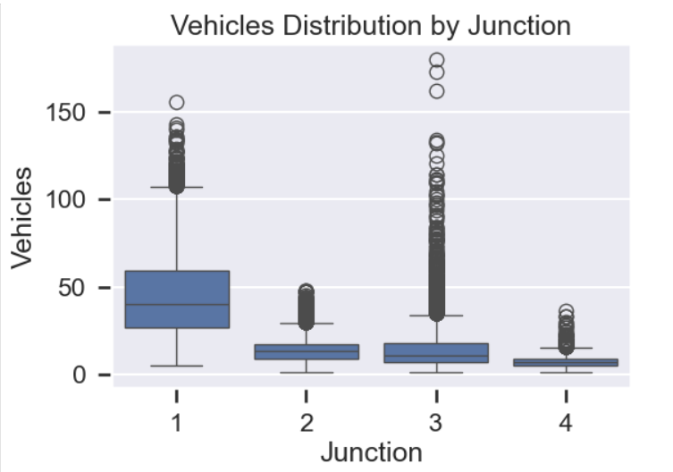
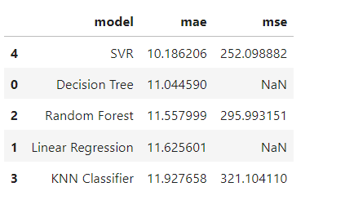
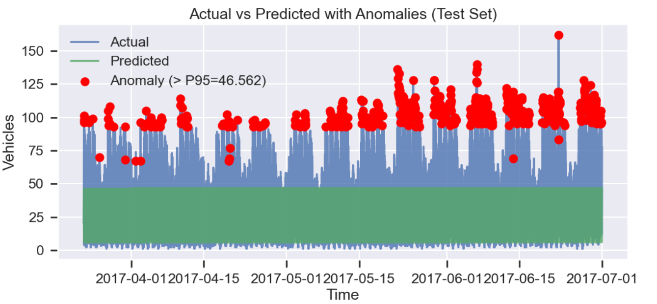

Lab 4:
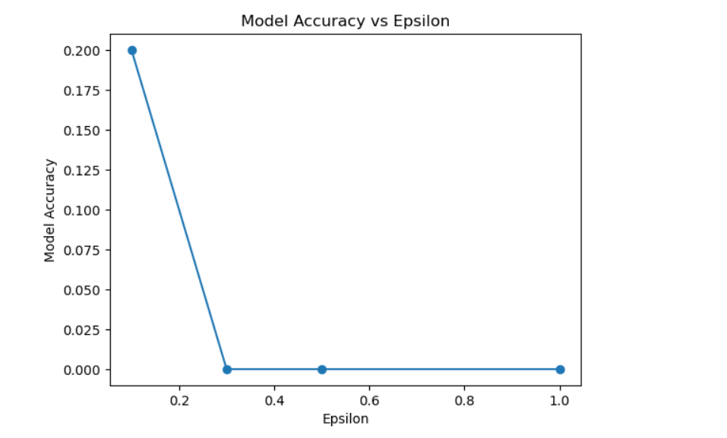
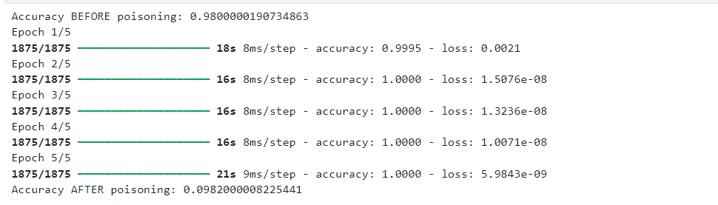

Lab 5:

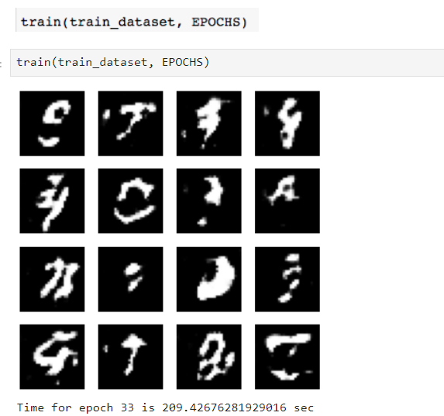

Lab 6 :

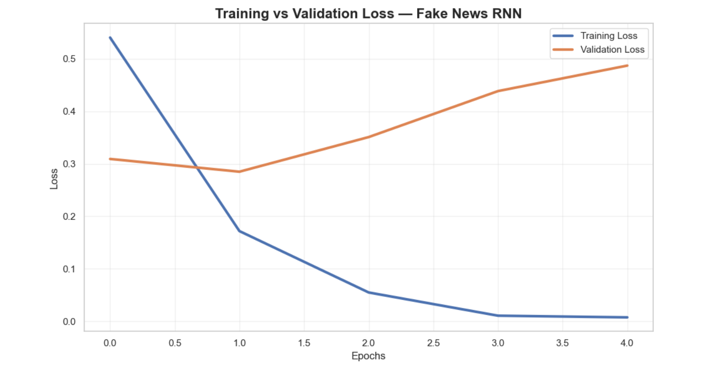

Lab 7 :

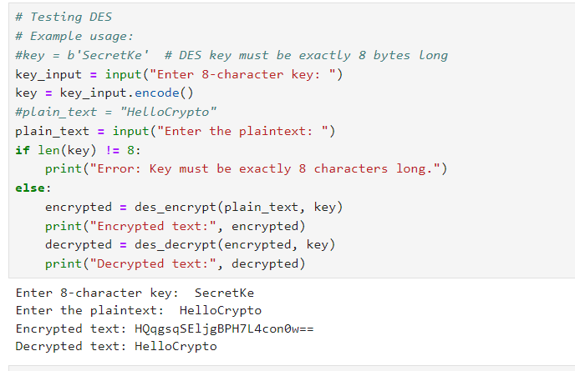
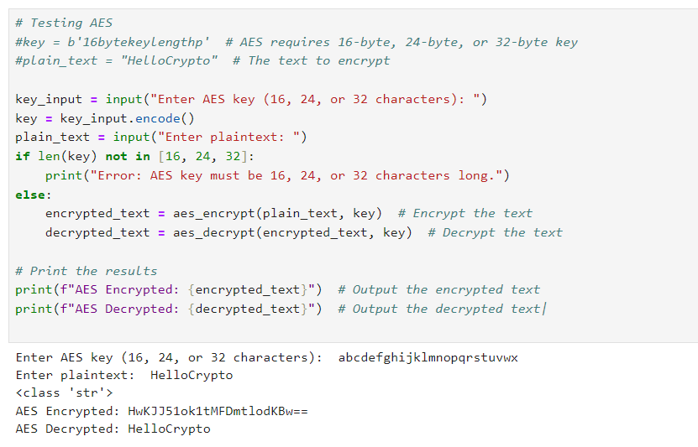
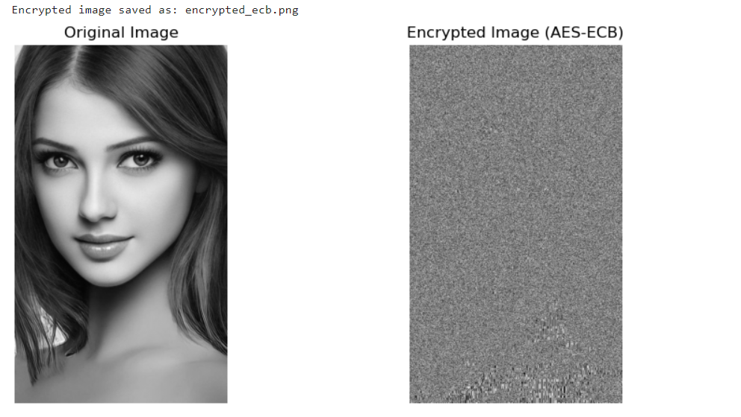



3. Explain in one word - 'YES' or 'NO' whether your encryption method for the images is good.
NO – because patterns are still visible

Lab 8 :
Your partner's name - Bharath shekar gudivada
Values: p, g, s, and your private key -

